**Fall**

14

**wesley.y.myers@gmail.com**

Weekly Status Report

Wesley Myers

October 6-13th, 2014

08

**Fall**

Table of Contents

Executive Summary 3

Architecture Design Change 3

Pan-Tilt Assembly and Testing 4

Laser-Camera Integration 5

Bill of Materials 6

Laser Testing 6

Raspberry Pi Installation 8

Formatting the SD Card 8

Windows 8

Mac 8

Linux 8

Installing the Operating System 8

Turning Off your Raspberry Pi 9

Getting Wifi Setup 9

Update Your Raspberry Pi 10

# Executive Summary

Milestones appear to be on track.

* Architecture Design Change
  + Addition of Arduino UNO
* Pan-Tilt Assembly and Testing
  + Servo range road block
  + Possible custom Servo Library for PWM
* Step 1 of Camera-Laser Integration
  + Analog output not good enough (Arduino ADC)
  + Serial communication roadblock
* Installation of Raspberry Pi

# Architecture Design Change

The CDR outlined that the Raspberry Pi would be controlling the servos and LRF platforms. Within the CDR under Risks, it was mentioned that the Raspberry Pi might not be the suitable controller to execute these operations. After more research, it has been determined that an Arduino UNO will be used as a Slave for the Raspberry Pi. The Raspberry Pi is not designed for the I/O that the Arduino UNO can handle, thus many projects have the Raspberry Pi as the Master, and the Arduino as the Slave. The devices work together to solve the problem.

Utilizing serial libraries, the Raspberry Pi will communicate with the Arduino UNO to command it to move the servos, as well as control the LRF measurements. The following diagram is the new System Architecture.

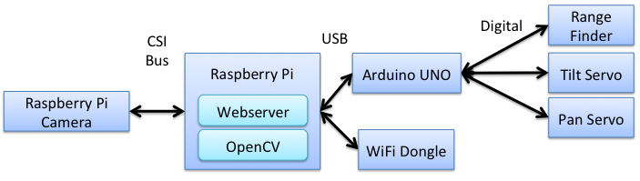

Figure - System Architecture

# Pan-Tilt Assembly and Testing

The SPT200 assembly was fairly straightforward. There were only few steps that seemed a bit unclear, but otherwise the system came together nicely.

Because of the design change to utilize the Arduino UNO to control the Servos, testing was rather simple. What was discovered during testing was that the servos do not appear to be utilizing the full 180-degree range. Meaning the 1-degree increments are more along the lines of 1.5-degree increments. This could prove to be problematic. To counter this, a custom servo library might need to be written for the Arduino to change the PWM signals.

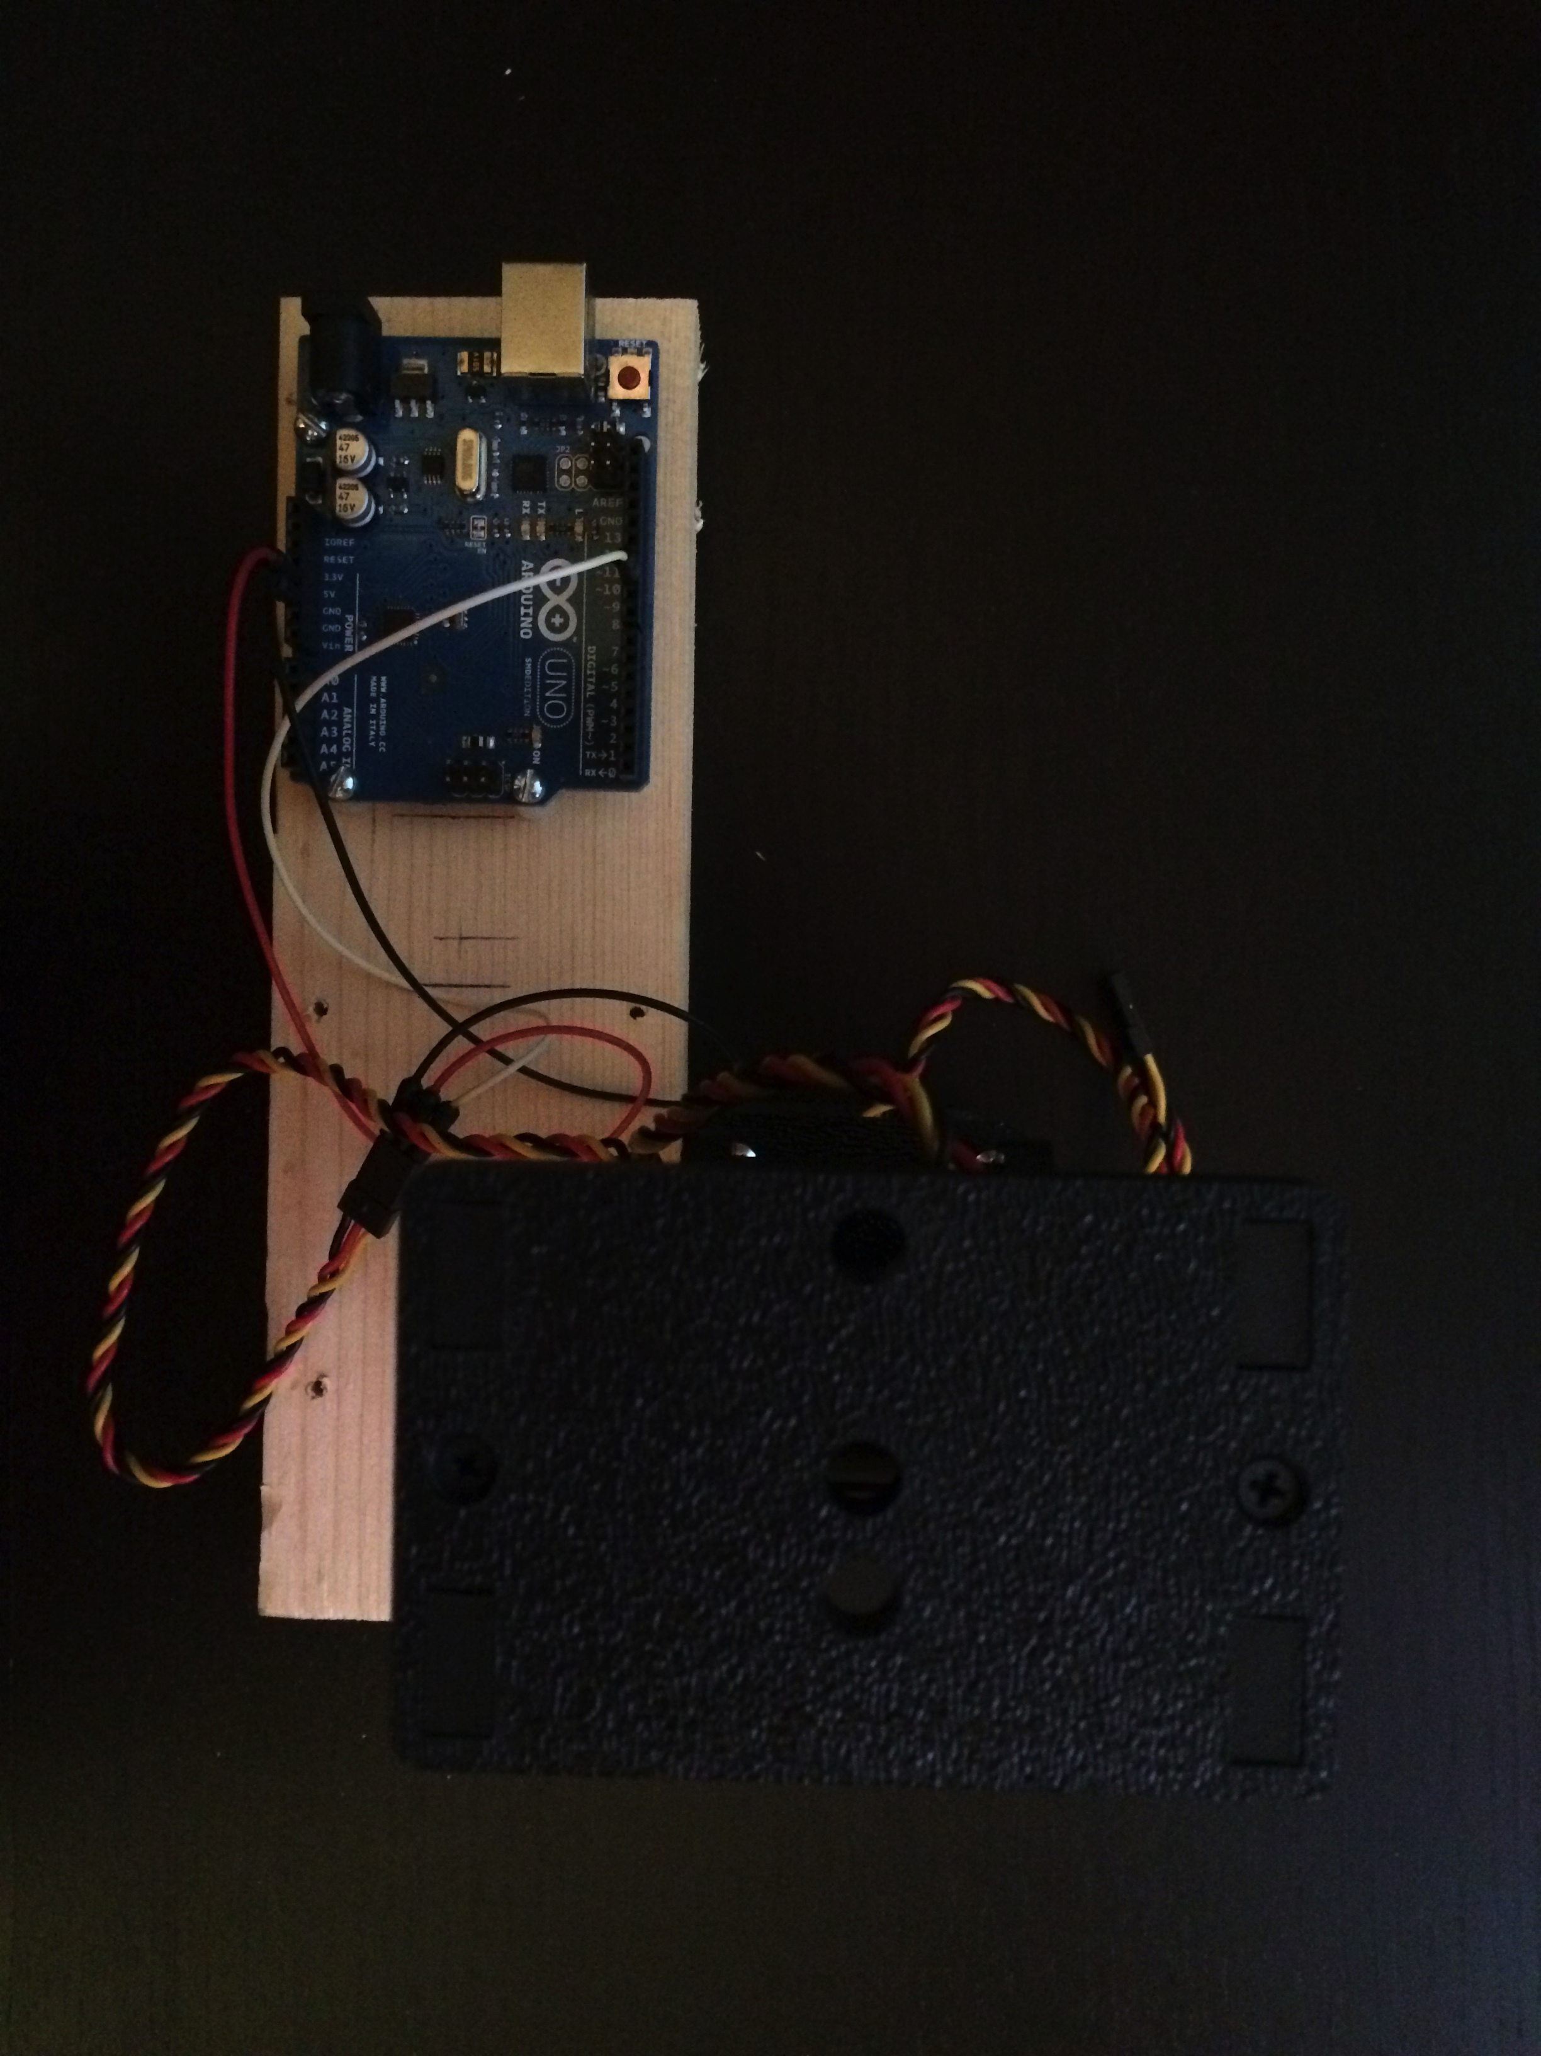

Figure - Servo Testing (Top View)

# Laser-Camera Integration

We quickly realized that what we need is a secure mount for the LRF, camera, and all hardware components before doing any real testing and development. With collaboration with the kind folks over at ACE Hardware in Baltimore, we came up with a solution to mount everything.

The solution was to use straphangers to firmly hold the laser in place. This made much more sense than trying to line up a bracket precisely to hold the laser. In this case, some sponge tape was applied to the strap and plank to help grip the laser. As access was needed to the USB port, the strap that holds the hardware in place is slightly offset.

The top board will consist of the laser and the camera. The bottom board will be connected to the pan-tilt and will house the Arduino UNO and Raspberry Pi. All connections should be available and not blocked by the brackets. Figure 3 shows how a bracket will be used to offset the two platforms. There is extra space since the current plan is to create a board that runs all of the connections between the laser, Raspberry Pi, and Arduino UNO.

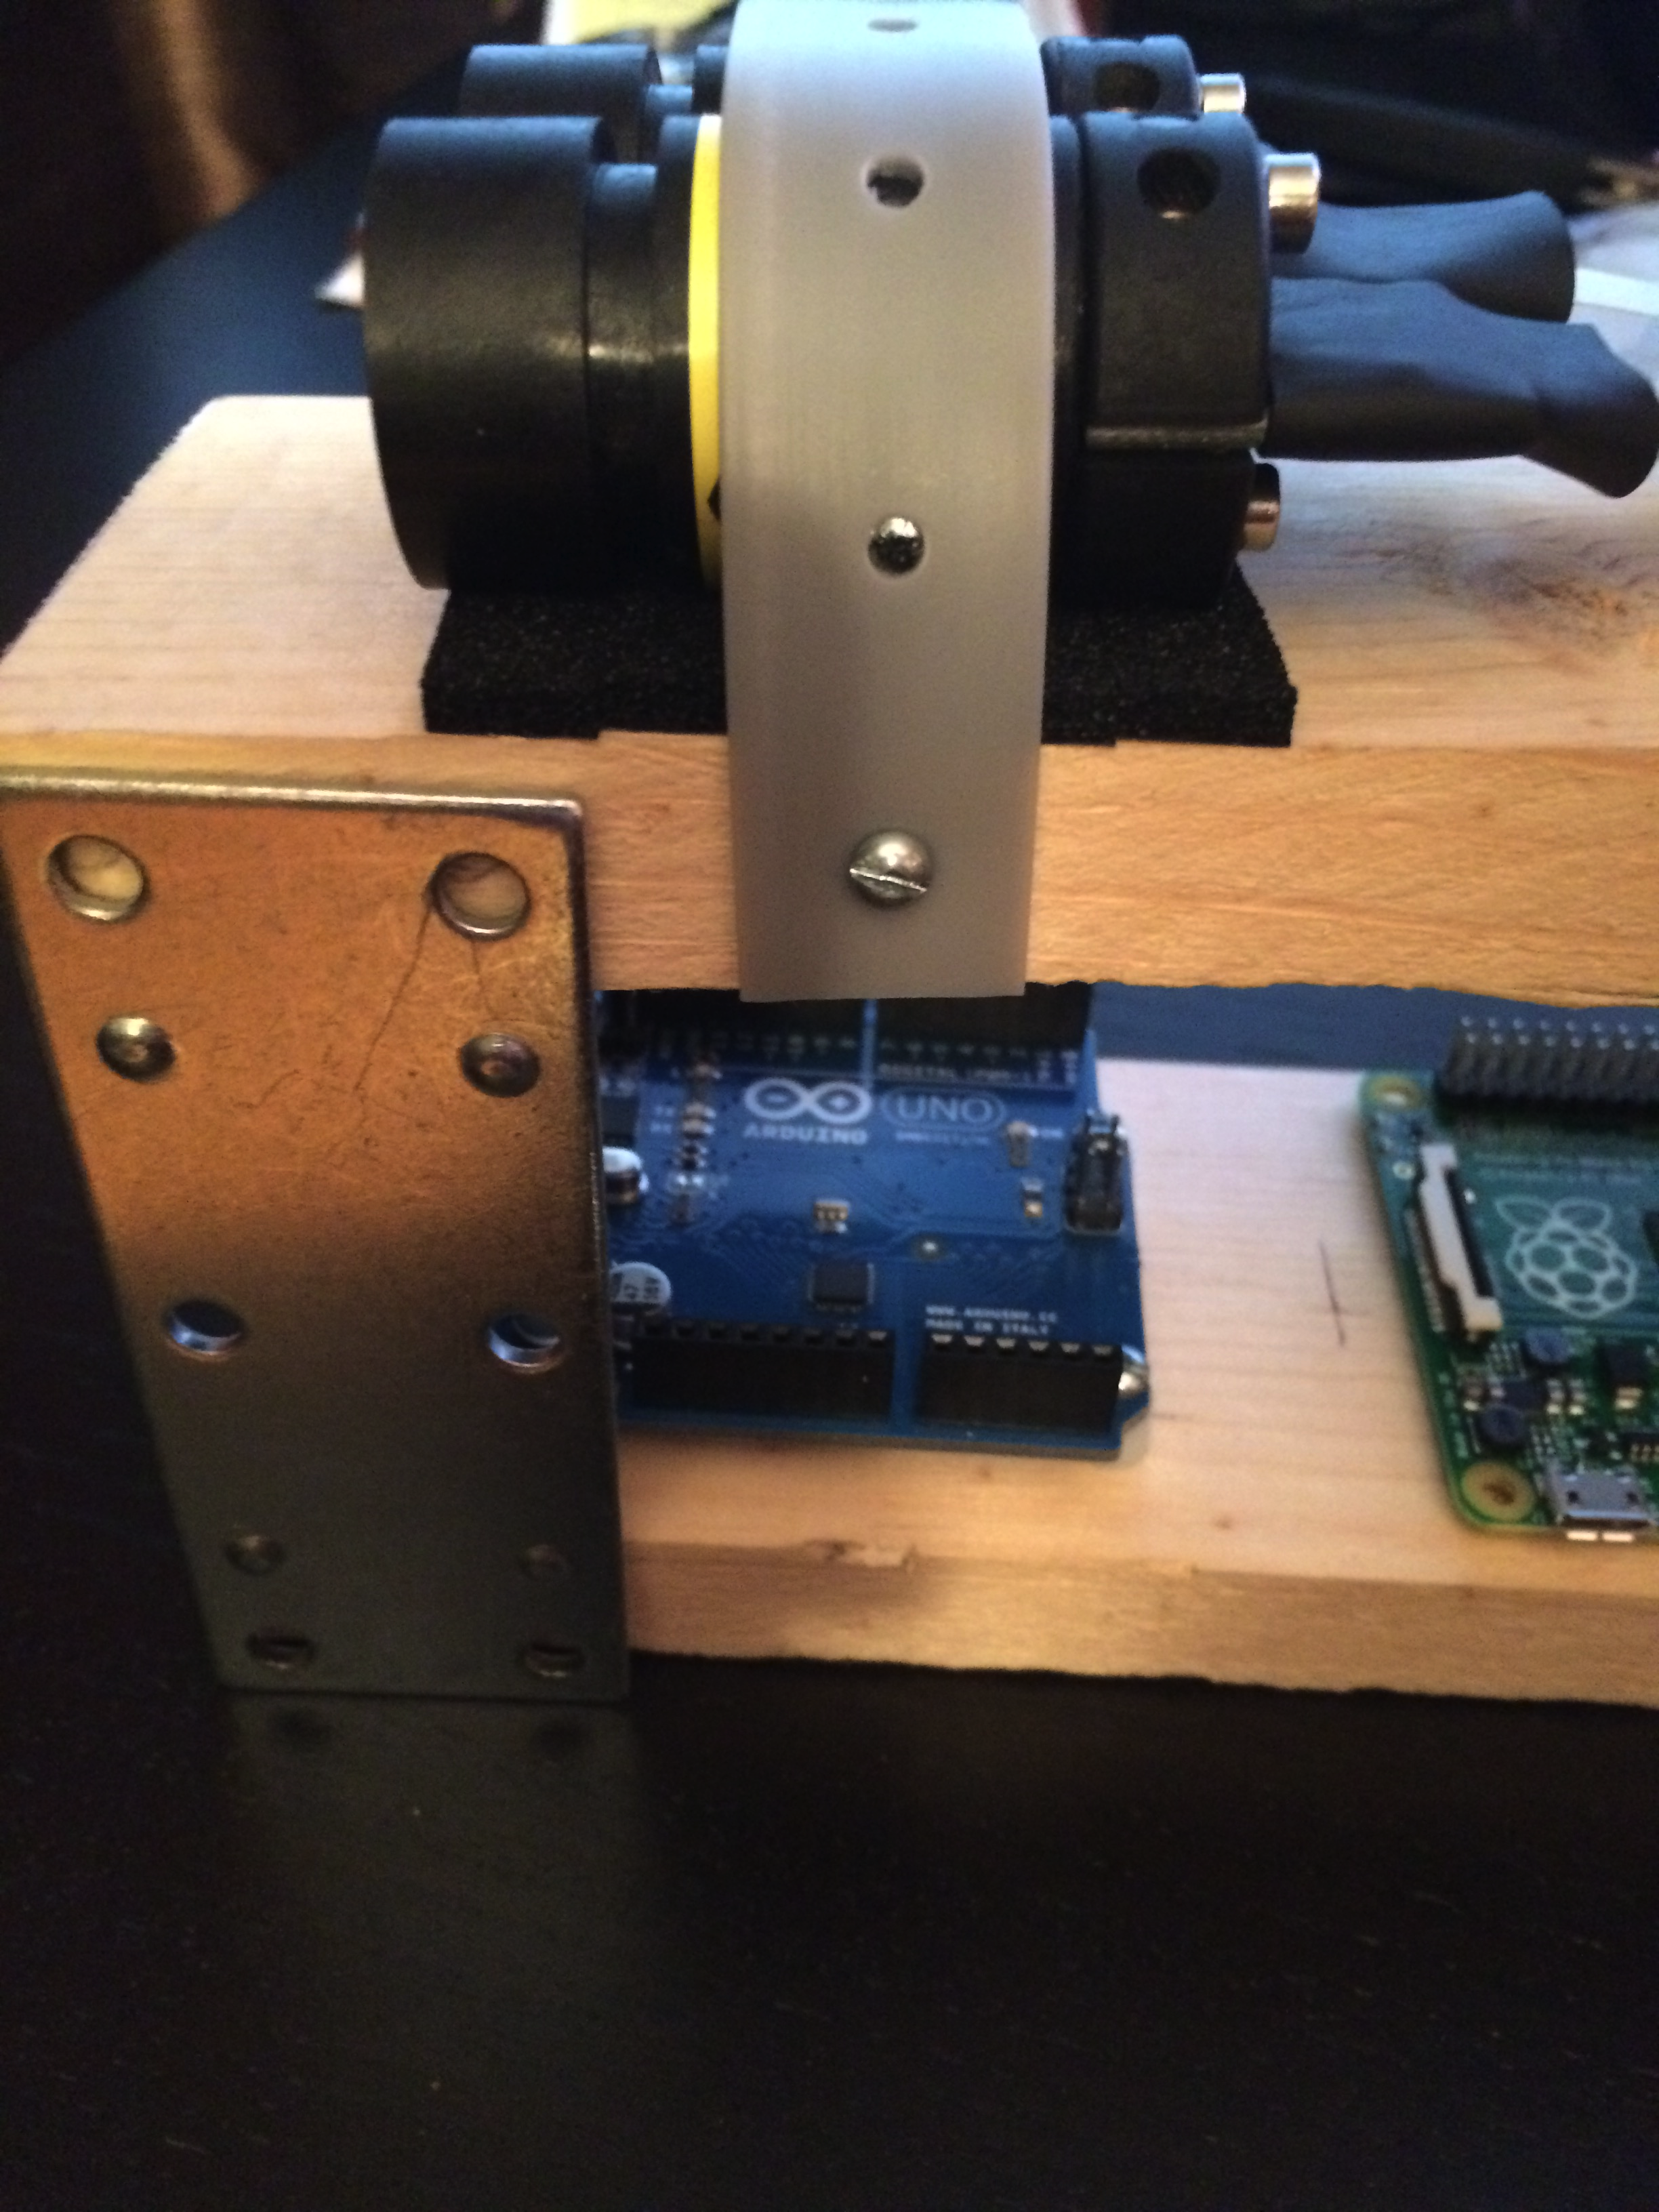

Figure - Unassembled Structure

Currently waiting on a much longer camera cable. It is on schedule to be delivered by the 17th. This cable is required because the current camera cable is 6 inches long. This is too short to reach from the top of the system to where the hardware is. In the original design, the laser/camera and Raspberry Pi were supposed to be all on the same platform. In which case a 6-inch cable would’ve been fine. However in this case, a longer cable is needed due to the change in height.

## Bill of Materials

The following are the extra materials purchased to support this chassis.

|  |  |  |
| --- | --- | --- |
| Description | Quantity | Cost |
| 8x2.5x.75 | 2 | $0 |
| Mending Braces | 1 | $4.99 |
| Strap Pipe Hanger | 1 | $3.49 |
| Sponge Tape | 1 | $3.99 |

## Laser Testing

With the Arduino starter code provided by LightWare, some initial testing was able to conducted with the laser. In this case, LightWare wants the user to configure some settings on the laser and adapt the code as necessary. In this case, the LightWare’s software runs on Windows and the lead engineer does not have access to a Windows machine. To make sure the laser was operational however, powering on the laser will provide an output voltage for the laser.

The following is output from the laser pointing at a wall, then at a piece of paper about a half meter away. What we can see is that there is some noise in the signal. This is partially due to the sensor and the ADC.

Analog = [0.35V] 3.48m

Analog = [0.36V] 3.58m

Analog = [0.35V] 3.53m

Analog = [0.34V] 3.43m

Analog = [0.04V] 0.44m

Analog = [0.04V] 0.39m

Analog = [0.05V] 0.54m

Analog = [0.33V] 3.33m

Analog = [0.32V] 3.23m

Analog = [0.35V] 3.48m

Analog = [0.04V] 0.44m

Analog = [0.04V] 0.44m

Analog = [0.05V] 0.49m

So in this case, we’re seeing a couple of things. So let’s do some math. The laser outputs a voltage between 0 and 3.3 V that represents the distance measured. So for our 5 V analog port, we’re already limiting ourselves a bit.

For our ADC, the Arduino UNO has a 10-bit ADC. So in this case we have 1024 different possible values.

$$\frac{5 V}{1024 samples}*\frac{60 meters}{3.3 V}= .08 \frac{m}{sample}$$

So that means using purely the analog pin, we’re getting terrible resolution. This means that serial communication with the laser is the way to go.

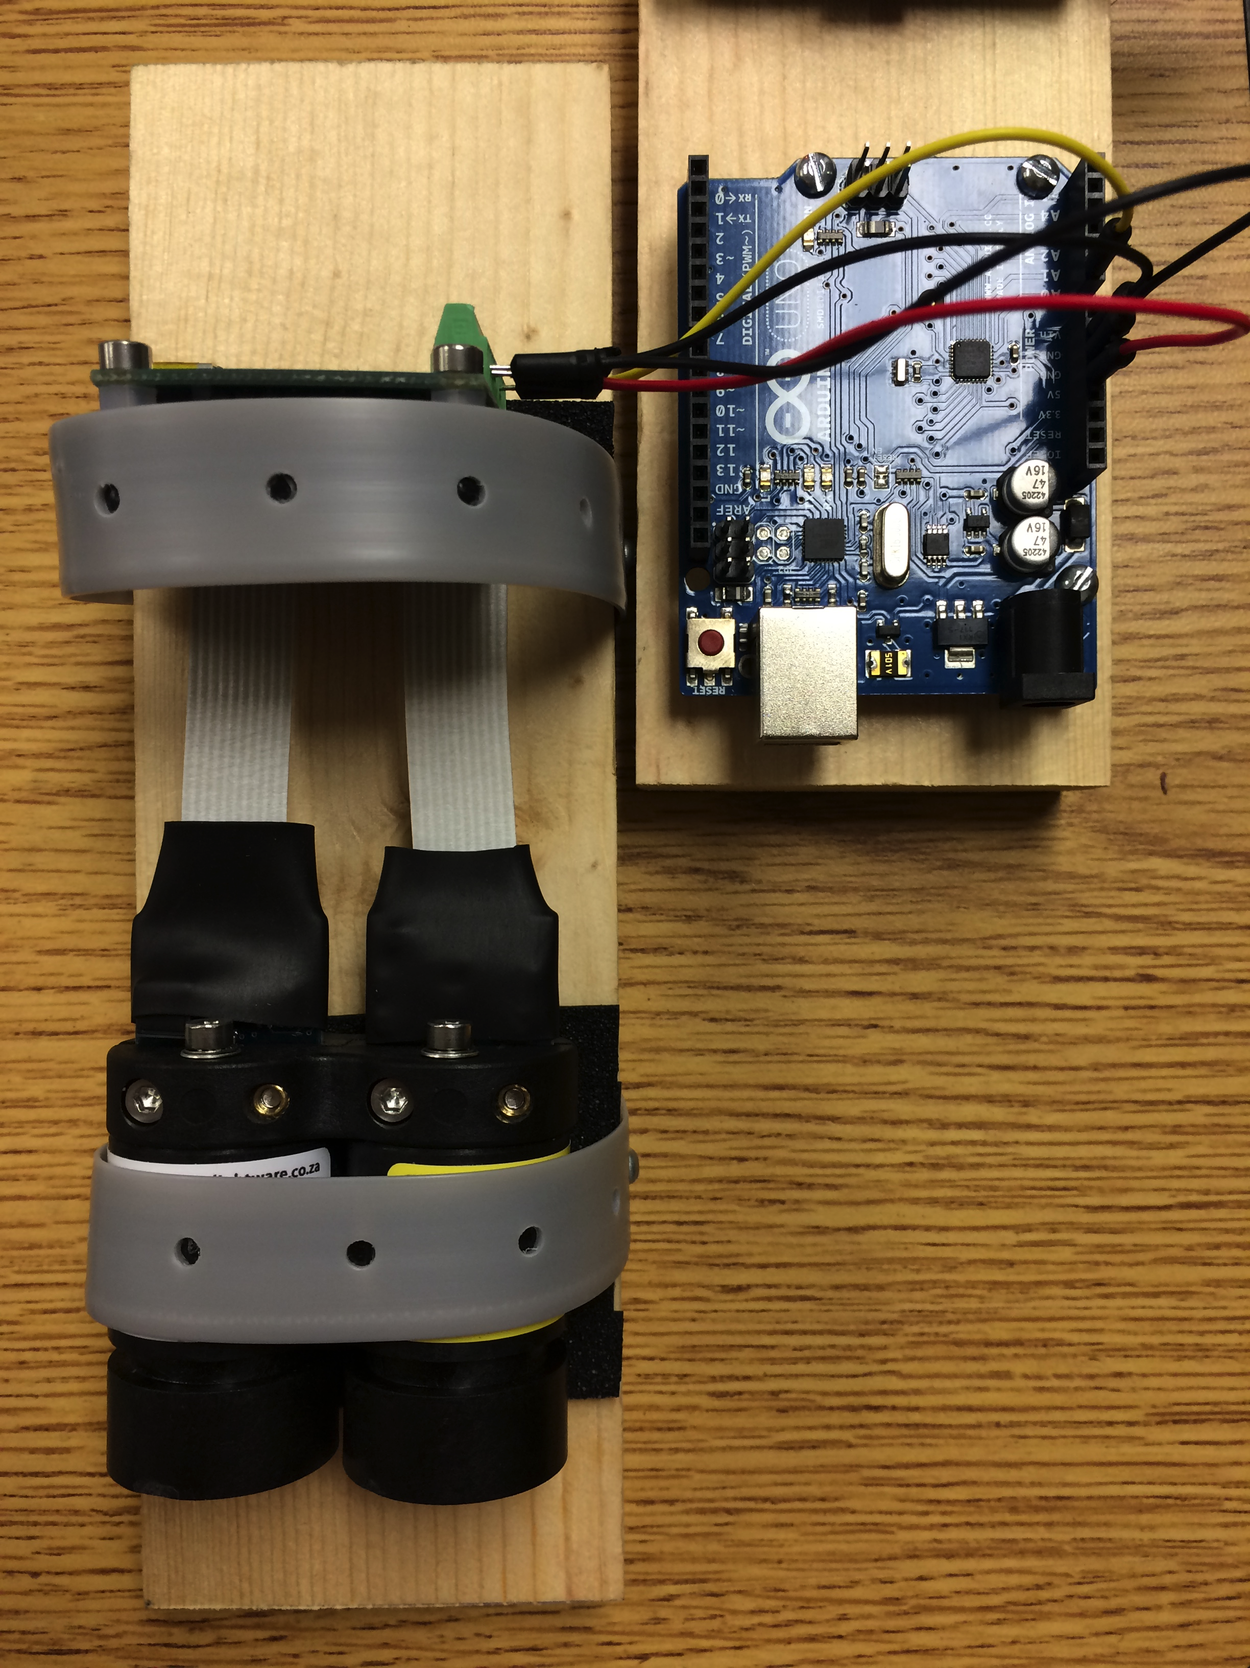

Figure - LRF and Arduino Configuration

# Raspberry Pi Installation

Setting up the Raspberry Pi is a rather time intensive process. This required installation of the default operating system for the Raspberry Pi, Raspian. This is a version of Linux Debian that is made for the Raspberry Pi. The following is documentation on how the Pi was set up.

## Formatting the SD Card

First things first is getting your SD Card all set up for the Raspberry Pi. Below are three sets of instructions given whether you have a Windows, Mac, or Linux machine.

### Windows

1. Download the SD Association’s Formatting Tool from <https://www.sdcard.org/downloads/formatter_4/eula_windows/>
2. Install and run the Formatting Tool on your machine
3. Set “FORMAT SIZE Adjustment” option to “ON” in the “Options” menu
4. Check that the SD card you inserted matches the one selected by the Tool
5. Click the “Format” button

### Mac

1. Download the SD Association’s Formatting Tool from <https://www.sdcard.org/downloads/formatter_4/eula_mac/>
2. Install and run the Formatting Tool on your machine
3. Select “Overwrite Format”
4. Check that the SD card you inserted matches the one selected by the Tool
5. Click the “Format” button

### Linux

1. Use gparted (or the command line version parted)
2. Format the entire disk as FAT

## Installing the Operating System

After your SD Card is formatted, extract the files from NOOBS[1] and drop it on the SD Card. Then plug the card into your Raspberry Pi. Make sure you have your keyboard wireless dongle plugged in. Now turn it on! Give it a few seconds and your Pi should show the following.

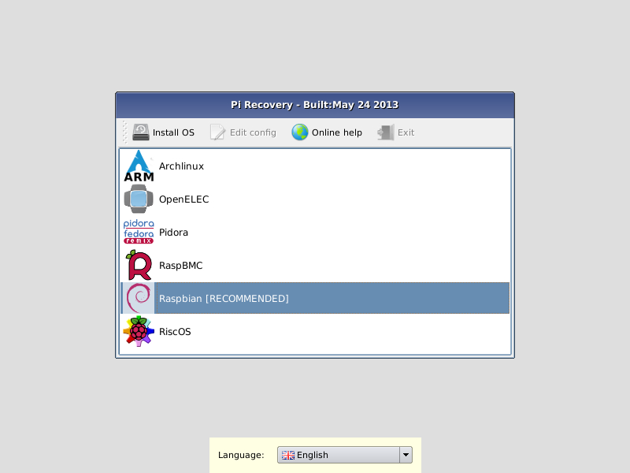

Choose Raspbian as your OS and it will proceed to install the Raspbian OS. This might take a while. If it takes more than an hour, then you probably have a bad SD Card.

Once this is all done, Raspberry Pi configuration will come up. Just skip to Finish at the bottom of the window.

## Turning Off your Raspberry Pi

DO NOT JUST UNPLUG THE POWER. This is very bad and you won’t do that to your own computer. Run the below shutdown command to properly shutdown the Pi and then remove the power. Not doing so could damage the file system and might be un-repairable!

sudo shutdown –h now

## Getting Wifi Setup

First make sure your Wifi dongle is plugged in. From the terminal, type in the below command

This should open up an editor that should show something similar to what is below. Edit this as necessary to match the below text.

sudo nano /etc/network/interfaces

auto lo

iface lo inet loopback

iface eth0 inet dhcp

allow-hotplug wlan0

auto wlan0

iface wlan0 inet dhcp

wpa-ssid "ssid"

wpa-psk "password"

Now reboot your Pi by typing the below command.

As your Pi is coming back up, you should be able to see some DHCP requests attempting to connect to the Wifi. If it can’t connect, then you should be able to see it attempt a couple of times and then say it couldn’t connect. If this is the case, then double check what was typed into that file.

## Update Your Raspberry Pi

Type in the below two commands to update your Raspberry Pi’s firmware. You will need Internet access to do this.

sudo apt-get update

sudo apt-get upgrade

sudo rpi-update

1. <http://downloads.raspberrypi.org/noobs>